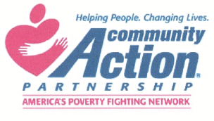
H. C. E. O. C.
Hawaii County Economic Opportunity Council
47 Rainbow Drive Hilo, Hawaii 96720
(808) 961-2681

Date:
Citric Acid Purchase
$60.00
Bags: _________________
Total Paid: _______________
Sold By: _______________

Buyer: ____________________________________________________________
Address: ___________________________________________________________
Phone #: ___________________________________________________________
District: ___________________________________________________________
Group/Association/ Club/Project if any: __________________________________

This citric acid not meant for internal consumption. HCEOC assumes no liability beyond that covered in its contract with the County of Hawaii. Please be careful and take all necessary and recommended precautions when using the citric acid.
Mahalo for your efforts in making our communities better places to live.
Staff Only:
VOUCHER #: ________________________

