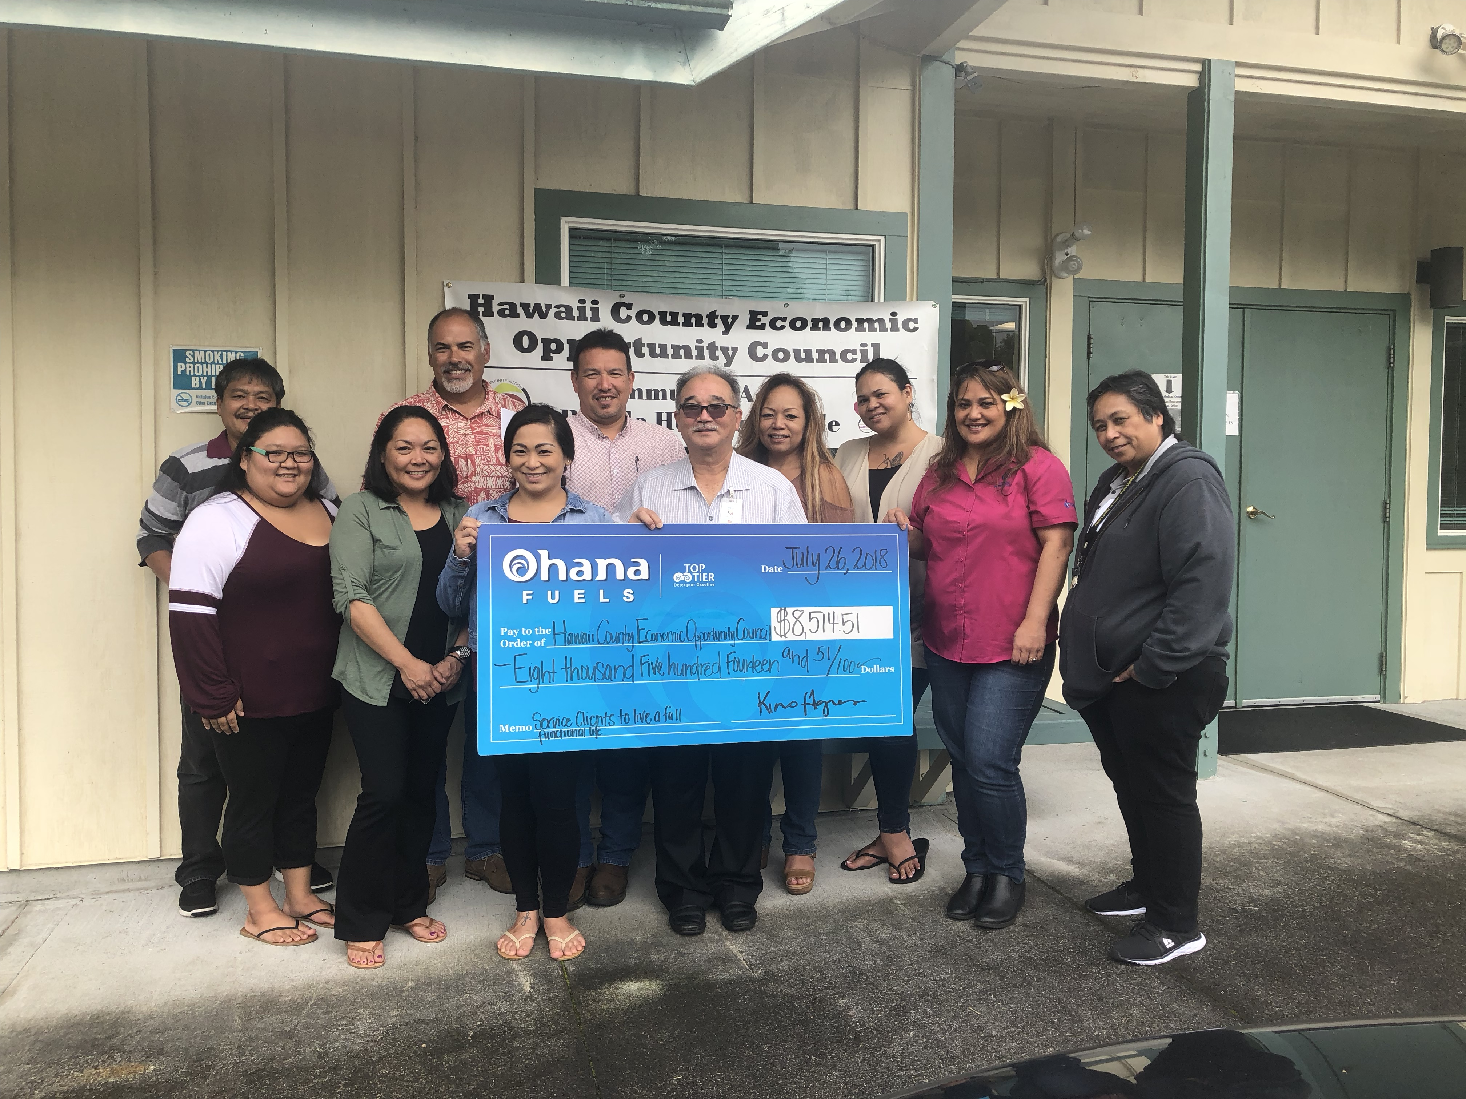

From Left, Kimo Haynes, President of Hawaii Petroleum Inc, Joy Madriaga, HFN & Commercial Marketing Rep. Hawaii Petroleum Inc., Jay T. Kimura, Hawaii County Economic Opportunity Council

FOR IMMEDIATE RELEASE

Hawaii County Economic Opportunity Council benefits from Ohana Fuels $8,514.51 donation

Hilo, Hawaii - On July 26, 2018, the Hawaii County Economic Opportunity Council (HCEOC) became the most recent beneficiary of the Ohana Fuels ‘Fuel Up. Do Good.’ program. Ohana Fuels partners with nonprofit organizations that serve the needs of the local community, and donates a portion of the proceeds from every gallon of gasoline purchased at Ohana Fuels stations in that community. Second quarter sales resulted in a donation to the Hawaii County Economic Opportunity Council in the amount of $8,514.51.

HCEOC is a Community Action Agency established in 1965 that strives to alleviate the symptoms of poverty and assist the most vulnerable in our community. The agency works through many programs including the Senior Farmers Market Coupon program, the Low income Housing Energy Assistance Program, and the Weatherization Assistance Program. In addition, they also provide transportation for handicapped, low-income, and senior clients, meals for students, housing preservation grants and education programs.

“The Board and Staff of Hawaii County Economic Opportunity Council are grateful for the generosity of Ohana Fuels in helping our organization, and the poor and vulnerable in our community,” said Jay Kimura, Executive Director. “These funds go a long way in supporting the HCEOC mission and in addressing the issues of poverty.”

Said Kimo Haynes, President of Hawaii Petroleum, “At Ohana Fuels we feel it is our duty to assist local non-profit organizations in supporting the residents of the neighborhoods where we do business. We value the exceptional work they do, and the services they provide to those in need.” He added, “To date, our ‘Fuel up. Do good.’ program has donated more than $319,000 to deserving organizations, and we look forward to offering continued support in the years to come.”

Ohana Fuels is Hawaii Petroleum’s retail fuel brand that provides competitively priced, quality fuels at safe, clean, and convenient locations including eight stations on the island of Maui, and eleven stations on the island of Hawaii. Certified as a TOP TIER™ fuel provider, Ohana Fuels meets the premier standard of gasoline for optimum performance and fuel efficiency. Hawaii Petroleum is committed to making a positive contribution to the communities in which our Ohana Fuels stations operate, and gives local residents a way to support the community with every tank of gas they purchase. Learn more at www.ohanafuels.com

CONTACT:
Jay T. Kimura

808-961-2681
hceocdirector@hceoc.net
HCEOC.NET

